1. Create a web page

ELC Engineers:

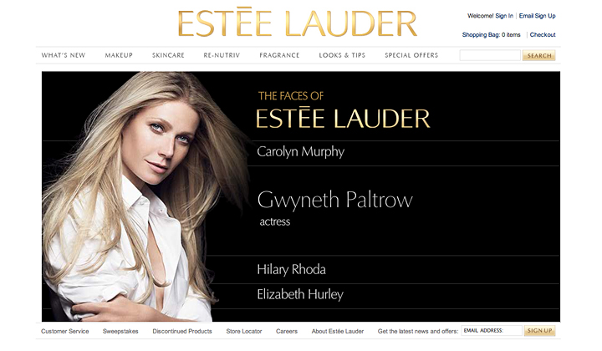

BCBS Engineers:

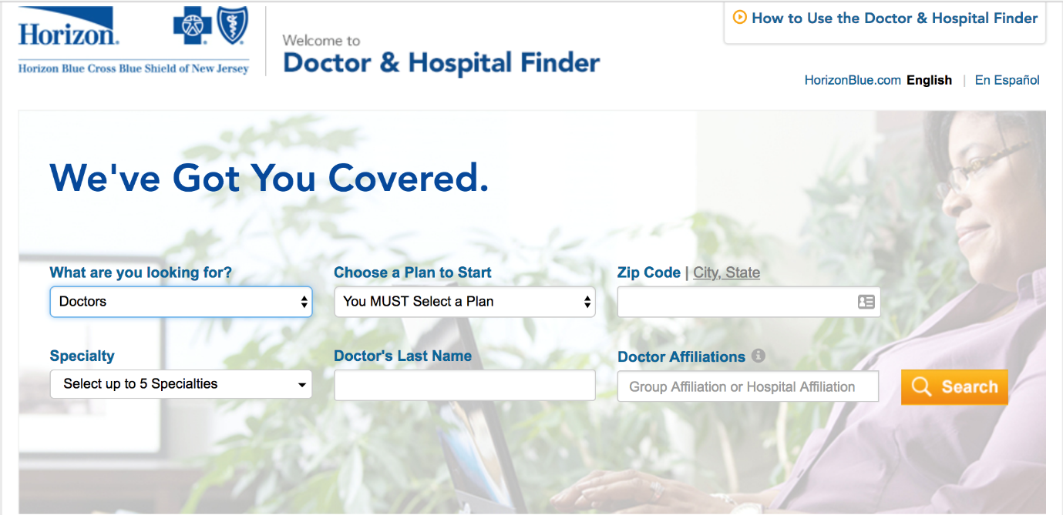

Equitas Engineers:



1. Create a web page which will contain three division and two buttons.
2. On the click of first button it will toggle the background color of three division between pink and white
3. On the click of second button it will toggle the border of three division between rounded border and no border.

Sample:

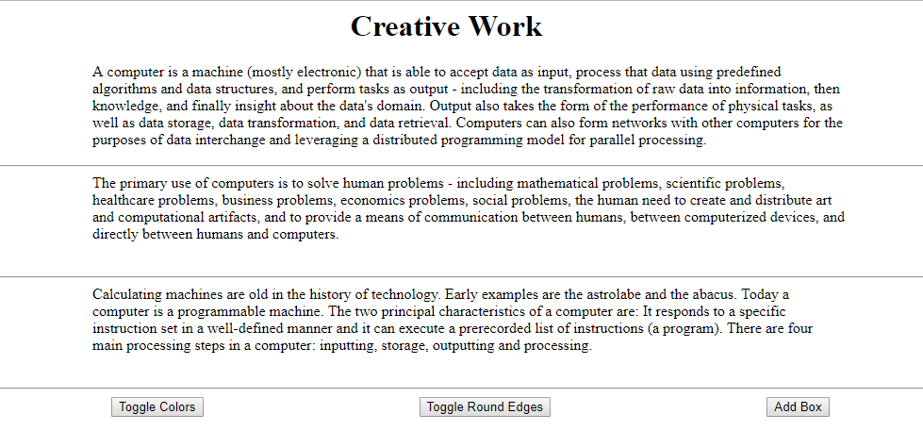

On click of Toggle Color button following will be the effect

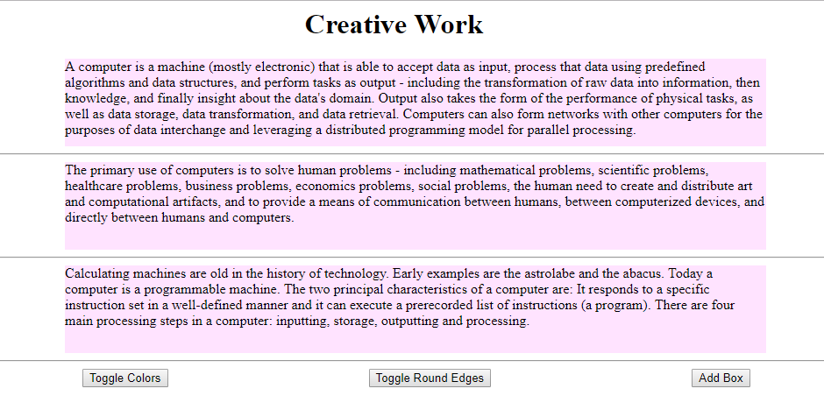

On the click of Toggle Round Edges following will be the effect

1. Write a Java program to calculate the sum of digits of a number.

